Topic: Mechanisms | Year group | Term
Design, make and evaluate a simple circuits board game for you and your friends to play in class | Year 4 | 6 sessions
Background knowledge
Parts can be connected in different ways to make linked parts move or react.
Parts can be connected in different ways
How to build a simple circuit (science)

Key learning in design and technology
Designing
• Gather information about needs and wants, and develop design criteria to inform the design of products that are fit for purpose, aimed at particular individuals or groups.
• Generate, develop, model and communicate realistic ideas through discussion and, as appropriate, annotated sketches, cross-sectional and exploded diagrams.

Making
• Order the main stages of making.
• Select from and use tools and equipment to cut, shape, join and finish with some accuracy.
• Select from and use materials and components, including construction materials and electrical components according to their functional properties and aesthetic qualities.

Evaluating
• Investigate and analyse a range of existing battery-powered products.
• Evaluate their ideas and products against their own design criteria and identify the strengths and areas for improvement in their work.

Technical knowledge and understanding
• Understand and use electrical systems in their products, such as series circuits incorporating switches, bulbs and buzzers.
• Apply their understanding of computing to program and control their products.
• Know and use technical vocabulary relevant to the project.

What should I already know
- Constructed a simple series electrical circuit in science, using bulbs, switches and buzzers.
- Cut and joined a variety of construction materials, such as wood, card, plastic, reclaimed materials and glue

National Curriculum Objectives / Key Skills | The Journey
National Curriculum Objectives  - Design purposeful, functional, appealing products for themselves and other users based on design criteria  - Generate, develop, model and communicate their ideas through talking, drawing, templates, and mock-ups.  - Select from and use a range of tools and equipment to perform practical tasks.  - Select from and use a wide range of materials and components according to their characteristics.  - Explore and use mechanisms, (sliders, levers, wheels and axles) in their products.  - Explore and evaluate a range of existing products  - Evaluate their ideas and products against design criteria  As a year 4 designer KPI  - I can explore and use existing products to help generate ideas about what my product needs.  - I can suggest some design criteria to suit the purpose and audience of the product.  - I can produce a plan and explain it, including exploded diagram/annotated sketch.  - I can make a product that uses simple electrical systems or computer programming to enhance it.  - I can independently select from a wider range of tools and explain my reasons for these.  - I can persevere and adapt the process to overcome problems  - I can evaluate my design against the criteria and suggest improvements for my design to others | - WALT: Discuss, investigate and where practical disassemble relevant battery powered products. . Where and why they are used? How does the product work? What are its key features and components? How does the switch work? Is the product manually controlled or controlled by a computer? What materials have been used and why? How is it suited to its intended user and purpose? Ask children to investigate examples of switches, including those which are commercially available, which work in different ways e.g. push-to-make, push-to-break, toggle switch. Let the children use them in simple circuits e.g. How might different types of switches be useful in different types of products?  - WALT: Investigate how circuits work; children shown the components and given chance to experiment. Recap with the children how to make manually controlled, simple series circuits with batteries and different types of switches, bulbs and buzzers. Discuss which of the components in the circuit are input devices e.g. switches, and which are output devices e.g. bulbs and buzzers.  - WALT: Design my final product; create a labelled diagram. • Develop a design brief with the children within a context which is authentic and meaningful.• Discuss with children the purpose of the battery-powered products that they will be designing and making and who they will be for. Ask the children to generate a range of ideas, encouraging realistic responses. Agree on design criteria that can be used to guide the development and evaluation of the children’s products, including safety features.• Using annotated sketches, cross-sectional and exploded diagrams, as appropriate, ask the children to develop, model and communicate their ideas.  - WALT: Make my final electrical board game product Ask the children to consider the main stages in making and testing before assembling high quality products, drawing on the knowledge, understanding and skills learnt through IEAs and FTs.  - WALT: Complete and finish my final product  - WALT: Evaluate my product against the criteria Evaluate throughout and the final products against the intended purpose and with the intended user, drawing on the design criteria previously agreed.

Outcomes
An overview of what children will know / can do

Working towards: With support can construct a simple electronic board game with support
Expected: I can design and construct a simple electric board game with minimal support.
Exceeding: I can add detail to create an interesting and well thought out electric board game

Key Vocabulary | Timeline / Diagrams
Design- The way the product is planned to look or behave  Program- set of instructions given to the product  Construct- make  Cell- battery  Wire- material made of rods or threads woven or twisted together.  Sparkle- Full colour LEDs | 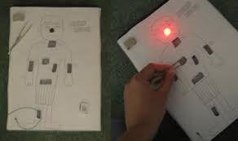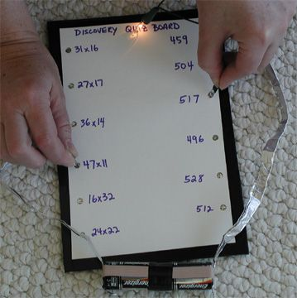

Key people / places
Thomas Alva Edison was a famous American inventor. He is best known for inventing 'domestic' lightbulbs to go in houses, and the electric power system that allows them to work. He came up with over 1000 successful inventions in his lifetime.

Resources
handling collection of battery-powered electrical products switches including toggle push-to-make and push-to-break
aluminium foil, paper fasteners, paper clips, card, corrugated plastic, reclaimed materials, finishing materials and media
buzzers, bulbs, bulb holders, zinc carbon or zinc chloride batteries, batteries, battery holders, wire, automatic wire strippers , suitable control program with interface box or standalone control box
right/left handed scissors, PVA glue, cutting mats

Assessment questions / outcomes
What is a circuit?
What kind of products could use simple circuits?
Name some components used in simple circuits?
How will your design meet the design criteria?
What problems did you overcome in programming your crumble?
How effective was your crumble?
How would you improve it next time?

