Topic: Building structures | Year Group | Sessions
Design, make and evaluate a bug house to entice bugs in to our forest school site. | Year 4 | 6 sessions
Background knowledge
An insect hotel, also known as a bug hotel or insect house, is a manmade structure created to provide shelter for insects. They can come in a variety of shapes and sizes depending on the specific purpose or specific insect it is catered to. Children will have an understanding of bug habitats through their science topic and forest school sessions.

What should I already know?
- Experience of using different joining, cutting and finishing techniques with paper, card and wood
- Different materials require different tools to shape and finish them.
- We can use a range of materials to make models or structures
- Wood can be used to make strong, stable structures using specific tools
- Wood can be cut and shaped carefully using saws and sandpaper
- Different ways to join wood to allow for a strong structure (picture frame project)
- A basic understanding of 2-D and 3-D shapes in mathematics and the physical properties and everyday uses of materials in science.
Key learning in design and technology
Designing
• Generate realistic ideas and design criteria collaboratively through discussion, focusing on the needs of the user and purpose of the product.
• Develop ideas through the analysis of existing products and use annotated sketches and prototypes to model and communicate ideas.

Making
• Order the main stages of making.
• Select and use appropriate tools to measure, mark out, cut, score, shape and assemble with some accuracy.
• Explain their choice of materials according to functional properties and aesthetic qualities.
• Use finishing techniques suitable for the product they are creating.

Evaluating
• Investigate and evaluate a range of existing shell structures including the materials, components and techniques that have been used.
• Test and evaluate their own products against design criteria and the intended user and purpose.

Technical knowledge and understanding
• Develop and use knowledge of how to construct strong, stiff shell structures.
• Develop and use knowledge of nets of cubes and cuboids and, where appropriate, more complex 3D shapes.
• Know and use technical vocabulary relevant to the project.

National Curriculum Objectives / Key Skills | The Journey
National Curriculum Objectives  - Design purposeful, functional, appealing products for themselves and other users based on design criteria  - Generate, develop, model and communicate their ideas through talking, drawing, templates, and mock-ups.  - Select from and use a range of tools and equipment to perform practical tasks.  - Select from and use a wide range of materials and components according to their characteristics.  - Explore and use mechanisms, (sliders, levers, wheels and axles) in their products.  - Explore and evaluate a range of existing products  - Evaluate their ideas and products against design criteria  As a year 4 designer KPI  - I can research and explore existing products to help generate ideas about design criteria.  - I can come up with a design to match design criteria.  - I can produce a plan and explain it, including cross-sectional sketch  - I can measure accurately to build a strong and stable structure  - I know how to work safely with new tools and materials.  - I can select from a wider range of tools and materials, (including wood) explaining my reasons for these.  - I can persevere and adapt the construction process to overcome problems  I can evaluate and suggest improvements for my design. | - WALT: Investigate existing bug house; shapes, different structure types etc. Together decide on design criteria-what does it need to have/be. Who is the product for?  - WALT: Explore and make choices about materials  Investigate materials that could be used to make their bughouses, test strength etc. and justify choices.  - WALT: Design my mini greenhouse  Create a cross sectional/annotated sketch of their bughouse showing what materials they will use/how corners will be joined.  - WALT: Test out my design using a prototype.  Using simple construction materials, create prototypes of the joins/shape of the structure to ensure there are no obvious problems. At the end of the lesson reflect on their plans with a partner and add any alterations to their design sheet in a different colour.  - WALT: Make my mini bughouse  Remind children how to work safely with materials and tools available.  - WALT: Evaluate my bughouse  How does it meet the design criteria. How would I improve it next time?

Outcomes
An overview of what children will know / can do

Working towards: Make a simple bughouse structure with support, out of basic materials.
Expected: Make a stable bughouse structure, justifying choices for materials, tools and techniques.
Exceeding: Think about the design of the bughouse, create a strong structure and finish to a high level.

Key Vocabulary | Timeline / Diagrams
Frame- a rigid structure that surrounds something  Purpose- Function of the product  Audience- the group of people the product is aimed at.  Structure- a building or object constructed of different parts.  Angle- The space where two points meet/space between two surfaces meeting.  Prototype- a model version of your finished product to check it will work.  Annotated sketch- a drawing of your design with added notes about the design or materials  Cross-Sectional Diagram- is if you would take a knife and cut through one side of a diagram to see the inside and outside in one picture.  Flow chart- A set of instructions that shows the steps as boxes of various kinds, and their order by connecting the boxes with arrows. | 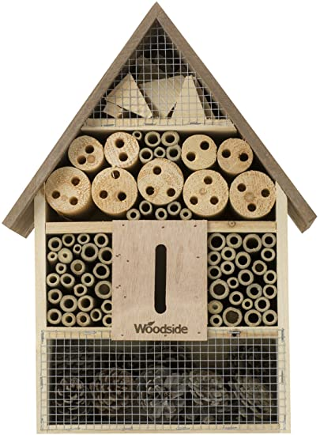  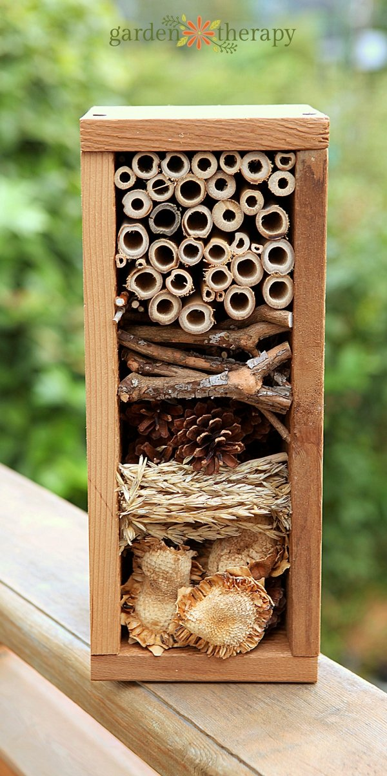

Key people / places
Use school forest school site to consider what bugs might use their bug house.

Resources
Card adhesive tape masking tape PVA glue glue spreaders pencils felt-tip pens rulers scissors cold glue guns Saws hand drills goggles Tool gloves

Assessment questions / outcomes
Which bughouse designs did you think are the most suitable? Why?
Which materials will you use to make your frame? Why?
Which materials will you use to make the inside of the bughouse?
How will you join your materials together?
Was your design successful? Why/why not?
How would you improve it next time?

