Topic: Structures | Year group | Sessions
Design, make and evaluate a house for a small creature living in a small world garden | Year 1 | 5 sessions
Background knowledge
Children investigate different types of houses in geography. They will build on their junk modelling knowledge from early years but with more focus and research into types of houses. Working with junk modelling materials allows them to explore a wide range of materials, ways to shape and join them, as well as allowing them to be creative and use their imagination.
What should I already know?
- Experience of using construction kits to build walls, towers and frameworks.
- Experience of using of basic tools e.g. scissors or hole punches with construction materials e.g. plastic, card.
- Experience of different methods of joining card and paper.

National Curriculum Objectives
Designing
- Generate ideas based on simple design criteria and their own experiences, explaining what they could make.
- Develop, model and communicate their ideas through talking, mock-ups and drawings.

Making
- Plan by suggesting what to do next.
- Select and use tools, skills and techniques, explaining their choices.
- Select new and reclaimed materials and construction kits to build their structures.
- Use simple finishing techniques suitable for the structure they are creating.

Evaluating
- Explore a range of existing freestanding structures in the school and local environment e.g. everyday products and buildings.
- Evaluate their product by discussing how well it works in relation to the purpose, the user and whether it meets the original design criteria.

Technical knowledge and understanding
- Know how to make freestanding structures stronger, stiffer and more stable.
- Know and use technical vocabulary relevant to the project.

Key Skills | The Journey
As a Year 1 designer KPI  - I can look at existing products and investigate the materials used to make them.  - I can explain my ideas to others and draw a picture of my design.  - I can use my own ideas to make something out of simple construction materials or junk modelling materials.  - I can choose appropriate resources and tools to cut, shape and join materials. (glue, tape)  - I can experiment with ways to make my structure stronger  - I can say what went well with my work | - WALT: Investigate how houses are different across the world. Go on a walk around the school grounds. What are the structures called? what is their purpose? Looks at the local houses from the school sight. What shapes are they? What are they built from? Compare these to pictures of houses around the world. Ask children to draw a picture of a structure and label with technical vocabulary  - WALT: Investigate joining materials together. Demonstrate measuring, marking out, cutting, shaping and joining materials. Explore attaching different shapes and pieces together-look at images; can they guess how it has been joined together? Can they recreate as a team?  - WALT: Design a junk model house As a class generate some simple design criteria. Encourage children to develop ideas by talking, drawing and making mock ups.  - WALT: Make a model house  As a whole class plan the order the structures will be made  - WALT: Improve my model- looking at how to make it stronger and sturdier.  - WALT: To evaluate the final product Discus how successful their house was against the design criteria set by class

Outcomes
An overview of what children will know / can do

Working towards: I can build a junk model
Expected: I can use my research to design and make a model house.
Exceeding: I can describe ways that I have made my model stronger and sturdier.

Key Vocabulary | Timeline / Diagrams
Strong- something that is able to withstand great force or pressure.  Weak – it breaks easily  Sturdy- something is able to hold itself up without falling over  Design- to make or draw plans for the structure or form  - Design Criteria – the goals that a project must achieve in order for it to be successful  Model – a small exact copy of something, often used as a guide to making the thing in full size  Structure-a thing made up of a number of parts joined together in a certain way.  Template – a pattern used as a guide for cutting or drawing  Stable – Does not topple over easily  Unstable – Topples over easily  Function- the purpose or role that an object fulfils or is suited for  Product- something made by means of either human work or that of a machine. | 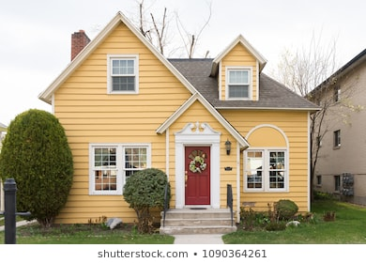  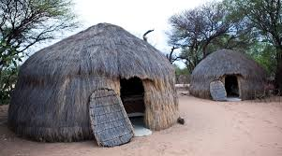  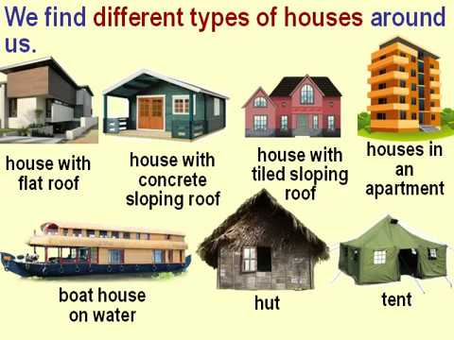

Key people / places
Buildings the children see locally
Morpeth
School sight
Resources
Photographs of various structures, construction kits that can be used to construct freestanding structures e.g. walls, towers, frameworks, paper, card, plastic sheet, paper and plastic straws, pipe cleaners, reclaimed materials including small containers, card boxes, cotton reels, string, masking tape , PVA glue, plasticine, left/right handed scissors, hole punch, stapler, finishing media and materials

Assessment questions / outcomes
How are houses different across the world?
Can you tell me some different materials houses can be made from?
Why have you chosen those materials to build your house?
How did you make your house stronger?
Were you happy with your finished house?

