Topic: Food and Nutrition | Year group | Term
Design, make and evaluate a fruit kebab for you to eat at the class party | Year 2 | 5 sessions
Background knowledge
Fruits come from all over the world, some are grown naturally in this country like apples, pears, berries and plums. Others have to be grown in special greenhouses/ conditions or come from other countries such as oranges (Spain/ America), bananas (South Africa/ Africa), mango (Asia), Kiwi (New Zealand), grapes (Europe)

What should I already know?
- The names of some vegetables and food types.
- Some experience of growing foods in Reception – beans, potatoes and strawberries.
- Experience of common fruit and vegetables under taking sensory activities
- Experiences of cutting soft fruit and vegetables using appropriate utensils
National Curriculum links
Designing
- Design appealing products for a particular user based on a simple design criteria
- Generate initial ideas and design criteria through investigating a variety of fruit and vegetables
- Communicate these ideas through talk and drawing

Making
- Use simple utensils and equipment to eg. peel, cut, slice, squeeze, grate and chop safely
- Select from a range of fruit and vegetables according to their characteristics eg. colour, texture and taste to create a chosen product

Evaluating
- Taste and evaluate a range of fruit and vegetables to determine the intended users preferences
- Evaluate ideas and finished products against design criteria including indented user and purpose

Technical knowledge and understanding
- Understand where a range of fruit and vegetables come from eg. Farmed, home grown
- Understand and use basic principles of a healthy and varied diet to prepare dishes, including fruit and vegetables are part of The eat well plate
- Know and use technical vocabulary relevant to the projects

Key Skills | The Journey
As a year 2 desiner KPI  - I know where a range of food comes from.  - I can show some understanding of what seasonality means.  - I can evaluate existing products to say what is good and bad  - I can think about the ingredients and flavours when I plan my design.  - I can show that I know how to work safely to cut, chop, peel and prepare healthy foods. I can cut and prepare food safely and hygienically  - I can evaluate my product | - WALT – Investigate where our favourite fruits come from -To know that fruit is grown all over the world and can vary in each country dependent on weather and many other factors. To be able to name some fruit grown here in the UK and when it can be harvested  - WALT: To describe taste and texture of different fruits and give their opinions on likes and dislikes. As a class discuss thee taste, smell, texture and appearance. Describe through talking and drawing using key vocabulary  - WALT: Design a fruit kebab recipe. Ask the children to think about what flavours they enjoyed and think would go together. Recap the importance of food hygiene, health and safety. Recap these skills and teach any new skills.  - WALT: Make a fruit kebab. Talk to the children about the stages of making, considering utensils and the poof processes that they have learnt  - WALT: To evaluate their product to assess their product against the success criteria made by the class.

Key Vocabulary | Timeline / Diagrams
Taste – the flavour of a food.  Fruit – a food that grows on trees or plants  Seasonal- Things grown in a specific season  Texture – the way a food feels  Skewer – a wooden stick  Chop – to cut into smaller pieces.  Peel – to remove the skin of a food  Grow – to go from a seed to a fruity or vegetable  Knife – a sharp utensil used to chop  Chopping board – a board for cutting foods  Soft - not firm or hard  Juicy - having a great amount of juice  Crunchy - having a great amount of juice  Sweet - having a taste like that of sugar or honey; not bitter, salty, or sour  Sticky - ending to stick to or hold on to something when touched  Sour- ending to stick to or hold on to something when touched | 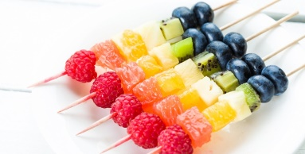  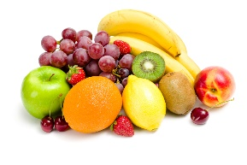  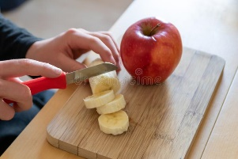

Outcomes
An overview of what children will know / can do

Working towards: I can prepare and chop fruit safely
Expected: I can design and make a fruit kebab, using my knowledge and opinion on fruit.
Exceeding: I can design and make a fruit kebab, making careful choices that I can justify to others.

Key people / places

Resources
Fruit and vegetable names Chopping boards Knives
Peelers Graters Skewers
Juicers Spoons Jugs
Plates Bowls Aprons
Plastic table covers Hand washing and washing up facilities

Assessment questions / outcomes
Can you identify the fruit?
Can you name some fruit grown in summer in the UK?
Can you name some fruit from other countries?
Can you say how to chop foods safely?
Can you explain why you’ve chosen these ingredients for your fruit kebabs?
Did you like your kebab?
What would you change?
Did it match your design?

