Topic: Food and Nutrition | Year group | Term
Design, make and evaluate a sandwich for you to eat as the class picnic. | Year 1 | 5 Sessions
Background knowledge
Moving pictures includes the different ways that you can make a picture move in a book, pop up is the most simple example of this, however in this unit children will focus mainly on using sliders and simple levers. They will need to build an understanding of how one part can affect another to design their Christmas cards.
What should I already know?
- The names of some vegetables and food types.
- Some experience of growing foods in Reception – beans, potatoes and strawberries.
National Curriculum Objectives
Designing
- Design appealing products for a particular user based on a simple design criteria
- Generate initial ideas and design criteria through investigating a Varity of fruit and vegetables
- Communicate these ideas through talk and drawing

Making
- Use simple utensils and equipment to eg. peel, cut, slice, squeeze, grate and chop safely
- Select from a range of fruit and vegetables according to their characteristics e.g. colour, texture and taste to create a chosen product

Evaluating
- Taste and evaluate a range of fruit and vegetables to determine the intended users’ preferences
- Evaluate ideas and finished products against design criteria including indented user and purpose

Technical knowledge and understanding
- Understand where a range of fruit and vegetables come from e.g. Farmed, home grown
- Understand and use basic principles of a healthy and varied diet to prepare dishes, including fruit and vegetables are part of The eat well plate
- Know and use technical vocabulary relevant to the projects

Key Skills | The Journey
As a year 1 designer KPI  - I can describe the taste and texture of food I’ve explored.  - I can explain where some foods come from.  - I can design something appealing and functional  - I can work safely with equipment  - I can cut and prepare food safely and hygienically  - I can explain what went well with my work and think what I could do to make it better. | - WALT: To describe taste and texture of different foods and give their opinions on likes and dislikes. As a class discuss thee taste, smell, texture and appearance. Draw pictures of vegetables they like and dislike  - WALT: Talk about food hygiene and practise technical skills. Look at different utensils and processes such as washing grating, peeling and slicing. Allow children to practice these and choose the best methods for preparing food  - WALT: Design a sandwich. Consider the design criteria and design their sandwich. Draw a design and think about ingredients and utensils they may need.  - WALT: To make a sandwich and taste the final product. Children to make their sandwiches following their design. Take pictures for later evaluation.  - WALT: To evaluate the final product Discus how successful their sandwich was against the design criteria set by class

Outcomes
An overview of what children will know / can do

Working towards: With support, I can design and make a sandwich.
Expected: I can design and make sandwich making independent choices based on what I like and do not like.
Exceeding: I can independently design and make a sandwich and explain my choices.

Key Vocabulary | Timeline / Diagrams
Taste – the flavour of a food.  Texture – the way a food feels.  Chop – to cut into smaller pieces.  Peel – to remove the skin of a food  Grow – to go from a seed to a fruity or vegetable  Knife – a sharp utensil used to chop.  Chopping board – a board for cutting foods.  Soft - not firm or hard  Juicy - having a great amount of juice.  Crunchy - having a great amount of juice.  Sweet - having a taste like that of sugar or honey; not bitter, salty, or sour.  Sticky - ending to stick to or hold on to something when touched.  Sour- ending to stick to or hold on to something when touched. | 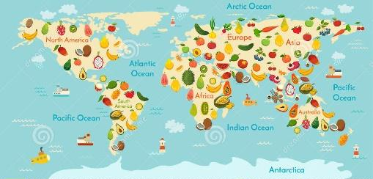  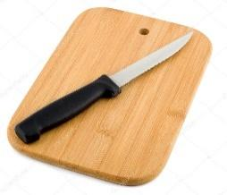

Resources
Fruit and vegetable names Chopping boards Knives
Peelers Graters Skewers
Juicers Spoons Jugs
Plates Bowls Aprons
Plastic table covers Hand washing and washing up facilities

Assessment questions / outcomes
Can you identify the foods?
Can you name some foods that are grown or sourced from this country?
Can you name some foods from other countries?
Can you say how to chop foods safely?
Can you explain why you have chosen these foods?
Did you like your sandwich?
What would you change?
Did it match your design?

Key people / places

