Topic: Building structures | Year Group | Sessions
Design, make and evaluate a batch of scones to sell at the school fair | Year 4 | 5 sessions
Background knowledge
A scone is a British baked good, usually made of wheat, or oatmeal with baking powder as a leavening agent and baked on sheet pans. A scone is often slightly sweetened and occasionally glazed with egg wash. Scones can also be savoury however (cheese and bacon, cheese and chilli etc.) and this is something which has become increasingly popular in recent years. This will build on festive baking (biscuits/cakes) children have done in earlier year groups, but will allow children to develop their understanding of flavours and adaptations to recipes, as well as baking techniques.
Key learning in design and technology
Designing
• Generate and clarify ideas through discussion with peers and adults to develop design criteria including appearance, taste, texture and aroma for an appealing product for a particular user and purpose.
• Use annotated sketches and appropriate information and communication technology, such as web-based recipes, to develop and communicate ideas.

Making
• Plan the main stages of a recipe, listing ingredients, utensils and equipment.
• Select and use appropriate utensils and equipment to prepare and combine ingredients.
• Select from a range of ingredients to make appropriate food products, thinking about sensory characteristics.

Evaluating
• Carry out sensory evaluations of a variety of ingredients and products. Record the evaluations using e.g. tables and simple graphs.
• Evaluate the ongoing work and the final product with reference to the design criteria and the views of others.

Technical knowledge and understanding
• Know how to use appropriate equipment and utensils to prepare and combine food.
• Know about a range of fresh and processed ingredients appropriate for their product, and whether they are grown, reared or caught.
• Know and use relevant technical and sensory vocabulary appropriately.

What should I already know?
- Biscuits and cakes are baked goods
- Ingredients can be mixed together and baked to produce a new product
- Know some ways to prepare ingredients safely and hygienically.
- Have some basic knowledge and understanding about healthy eating and The eatwell plate.
- Have used some equipment and utensils and prepared and combined ingredients to make a product.

National Curriculum Objectives / Key Skills | The Journey
National Curriculum Objectives  - Design purposeful, functional, appealing products for themselves and other users based on design criteria  - Generate, develop, model and communicate their ideas through talking, drawing, templates, and mock-ups.  - Select from and use a range of tools and equipment to perform practical tasks.  - Select from and use a wide range of materials and components according to their characteristics.  - Explore and use mechanisms, (sliders, levers, wheels and axles) in their products.  - Explore and evaluate a range of existing products  - Evaluate their ideas and products against design criteria  As a year 4 designer KPI  - I can use existing products for ideas for my own product.  - I can investigate popular flavours in existing products.  - I can design an appealing product  - I can produce a plan and write an ingredients list to prepare.  - I can draw an annotated sketch or cross-sectional diagram for my product.  - I can explain my choices for ingredients.  - I can measure accurately to carry out a recipe.  - I can show understanding of how ingredients should be stored and can be cooked in different ways.  - I can show that I know how to work hygienically | - WALT: To investigate Scones as part of British culture, how did people adapt and develop their recipes over the years eg. How did WW2 affect these traditions? How could we use this knowledge to adapt a simple scone recipe today?  Taste and explore different products to look at variety and flavours.  - WALT: Work as a class to make a design criteria. Look at the design criteria. Make informed choices about flavours and ingredients, explain choices to others. Present in an annotated sketch/cross-sectional diagram. Write an ingredients list.  - WALT: Research how to make scones. Watch a demo/video of how to make scones, discuss where they would adapt their methods to add in their own flavours. Write a plan/ simple recipe.  - WALT: To make scones in pairs or groups  - WALT: To evaluate product, say how it met the design criteria. Ask for peer feedback. Suggest ways they would change their recipe next time.

Outcomes
An overview of what children will know / can do

Working towards: I can follow a simple recipe to bake a product
Expected: I can follow my own recipe, choosing ingredients carefully to make a product
Exceeding: I can show I understand how a recipe could be adapted to suit differing diets

Key Vocabulary | Timeline / Diagrams
Baking- A method of preparing food using an oven.  Tradition- Customs being passed down through generations  Cream Tea/Afternoon Tea-  Rationing-controlled distribution of some food goods such as sugar, particularly during War times  Adapt- To change something-make a change to a recipe  Recipe- A step by step guide to making a product  Flavours- the taste of the food  Balanced diet- eating healthy amounts of the different food groups. | 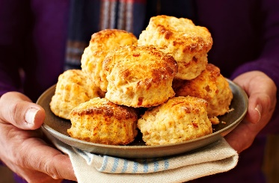  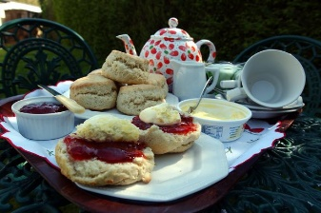  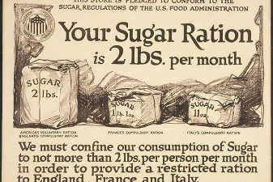

Key people / places
Great Britain
Germany

Resources
information about foods from around the world basic recipes range of relevant example foods to taste and evaluate
knives, chopping board, weighing scales, measuring jugs, bowls, baking trays, spoons – various sizes, parchment paper, plastic film

Assessment questions / outcomes
How did events like WW2 affect national tradition and recipes?
Can you name some different ways scones can be flavoured?
Can you say why you chose the ingredients you did for your recipe?
Can you describe the key steps in a scone recipe?
Did you like your finished scones?
What would you change next time?
Did your design match the design criteria?
How could your recipe be adapted for someone with a different diet? Eg. Vegetarian/low sugar?

