Topic: Mechanisms | Year group | Term
Design, make and evaluate a soup for you to eat in order to stay warm at forest school. | Year 3 | 6 sessions
Background knowledge
Soup is served all over the world and is part of many cultural/national food traditions. It has always been a cheap option of creating a healthy meal, and so has been recreated with differing flavours and ingredients across the world. They can be served hot, or cold (Gazpacho). Soups can be made easily and cheaply using seasonal vegetables, by growing them, buying them from a market or a local green grocer/supermarket.
Autumn: Cabbage, Carrot, celery, Cauliflower, Leeks, Onions, Parsnips, Potatoes, Pumpkins, Broccoli, Spinach, Mushrooms
Winter: Cabbage, Carrot, celery, Cauliflower, Leeks, Onions, Parsnips, Potatoes, Pumpkins, Broccoli, Spinach
Spring: Asparagus, Carrots, Cabbages, Cauliflower, Cucumber, Lettuce, Radish, Red onion
Summer: Beans, Beetroot, Broccoli, Cauliflower, Courgette, Onion, Potato, Tomatoes,

What should I already know?
- Names of some vegetables, Some Vegetables that are grown in the UK
- Utensils and Equipment used for chopping or peeling food safely
- Flavours and Textures can vary
- Food is different around the world
- Know some ways to prepare ingredients safely and hygienically.
- Have some basic knowledge and understanding about healthy eating and The eatwell plate.

National Curriculum Objectives
Designing
• Generate and clarify ideas through discussion with peers and adults to develop design criteria including appearance, taste, texture and aroma for an appealing product for a particular user and purpose.
• Use annotated sketches and appropriate information and communication technology, such as web-based recipes, to develop and communicate ideas.

Making
• Plan the main stages of a recipe, listing ingredients, utensils and equipment.
• Select and use appropriate utensils and equipment to prepare and combine ingredients.
• Select from a range of ingredients to make appropriate food products, thinking about sensory characteristics.

Evaluating
• Carry out sensory evaluations of a variety of ingredients and products. Record the evaluations using e.g. tables and simple graphs.
• Evaluate the ongoing work and the final product with reference to the design criteria and the views of others.

Technical knowledge and understanding
• Know how to use appropriate equipment and utensils to prepare and combine food.
• Know about a range of fresh and processed ingredients appropriate for their product, and whether they are grown, reared or caught.
• Know and use relevant technical and sensory vocabulary appropriately.
Key Skills | The Journey
As a year 3 designer KPI  - I can investigate and evaluate existing products to help inspire my design.  - I understand what a healthy diet looks like.  - I can design an appealing product and write an ingredients list.  - I can make informed choices about the ingredients I choose.  - I can follow a step by step plan to prepare my product.  - I can use equipment safely and hygienically when preparing my food.  - I can prove that my design meets the criteria (Checklist | - To know how soups vary across the world depending on the ingredients available and is used as a cheap healthy meal for families. Highlight how soups are a good way to maintain a healthy diet  - To taste a range of seasonal soups to describe taste and texture. Explain what they like and don’t like about them. Discuss what flavours went well together. I know how seasoning, herbs and spices is used to enhance flavour.  - Look at the design criteria: Design a healthy, tasty soup. Plan a recipe in a group thinking about what flavours they enjoyed and think would go together. Use knowledge of healthy diet from science. Write a list of ingredients they will need.  - Learn how to make soup correctly and safely. (eg. Modelled or from a video) Write a recipe for their soup – could be through a story map.  - To make soup in pairs or groups  - To evaluate product, say how it met the design criteria.

Outcomes
An overview of what children will know / can do

Working towards: I can prepare vegetables and make soup with support
Expected: I can design and make a soup, thinking about ingredients I want to use and working safely.
Exceeding: I can design and make a soup, making careful choices that I can justify to others.

#Key Vocabulary | Timeline / Diagrams
Vegetable- a food that grows under or on the ground.  Seasonal- Things grown in a specific season  Seasoning- Additional ingredients added to a soup mix to enhance the flavours (eg. Herbs, spices, salt and pepper)  Taste – the flavour of a food.  Texture – the way a food feels.  Chop – to cut into smaller pieces.  Peel – to remove the skin of a fruit.  Grow – to go from a seed to a fruit.  Knife – a sharp utensil used to chop.  Chopping board – a board for cutting foods.  Types of vegetable:  Carrots  Onions  Potatoes  Pumpkin  Parsnips  Herbs:  Parsley, thyme, rosemary | 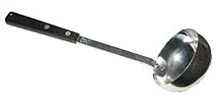  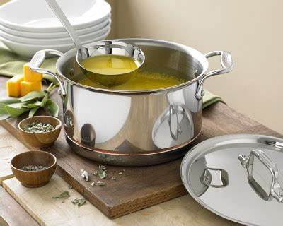  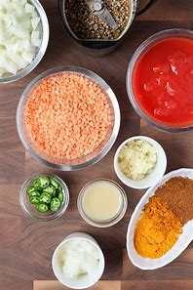  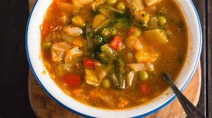  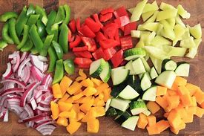

Resources
information about foods from around the world , basic recipes, range of relevant example foods to taste and evaluate,
knives, chopping board, weighing scales, measuring jugs, bowls, baking trays, spoons – various sizes, parchment paper, plastic film

Key people / places
Stone age stew linked to topic work

Assessment questions / outcomes
Can you name the different food groups that need to be represented in a healthy diet?
Can you say how to cook soup safely?
Can you explain why you’ve chosen these ingredients for your soup?
Did you like your soup?
What would you change?
Did your design match the design criteria?

