Topic: Mechanisms | Year group | Term
Design, make and evaluate a dune buggy for a lifeguard to help make travelling on the beach easier. | Year 2 | Summer 2
Background knowledge
The wheel and axle is a machine consisting of a wheel attached to a smaller axle so that these two parts rotate together in which a force is transferred from one to the other.
What should I already know?
- Assembled vehicles with moving wheels using construction kits
- Explored vehicles through play
- Some experience of designing, making and evaluating products for a specific user and purpose
- Developed some cutting, joining and finishing skills with card.

National Curriculum Objectives
Designing
- Generate initial ideas and simple design criteria through talking and using own experience
- Develop and communicate ideas through drawings and mock-ups

Making
- Select from and use a range of tools and equipment to preform practical tasks such as cutting and joining to allow movement and finishing
- Select from and use a range of materials and components such as paper, card and plastic and wood according to their characteristics

Evaluating
- Explore and evaluate a range of products with wheels and axis
- Evaluate their ideas throughout and their products against original criteria

Technical knowledge and understanding
- Explore and use wheels, axle and axle holders.
- Distinguish between fixed and freely moving axles
- Know and use technical vocabulary relevant to the projects

Key Skills | The Journey
As a year 2 designer KPI  - I can evaluate existing products to understand how they work.  - I can think about the purpose and audience when I come up with my design.  - I can think of an idea and plan what to do next  - I can use my ideas to make something that moves using wheels or axels.  - I can make informed choices about tools and materials  - I can join materials in different ways (glue, tape, fasteners)  I can check if my design is suitable for the purpose | - WALT: Understand how wheels and axels work.  Explore and evaluate a range of wheeled products such as toys and everyday objects Draw an example of a wheeled product, stating the user and purpose and label the main parts.  - WALT: Make a wheel and axel mechanism.  Focused Tasks- Model how to make the mechanism. Children experiment with the wheels and axels. Draw and label or take pictures.  - WALT: Design a moving product- With the children identify a user and a purpose for the product. Share ideas through talk and drawing. Give opportunity to evaluate ideas.  - WALT: Make wheels and axels to make a moving product – Make wheel and axel product using their design ideas and criteria as they go.  - WALT: Make wheels and axels to make a moving product - Complete making the product, decorate and test?- take photos for later evaluation.  - WALT: Evaluate my product – Children to evaluate their finished product, communicating how it works and how it matched their design criteria, including any changes they have made.
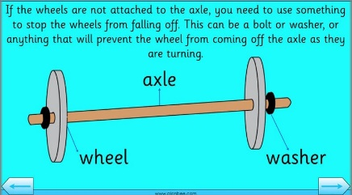
Outcomes
An overview of what children will know / can do

Working towards: I follow instructions and work with support to make a wheel and axel mechanism.
Expected: I can make a wheel and axel mechanism to make a product move
Exceeding: I can make an appealing moving toy that is finished well
Key Vocabulary | Timeline / Diagrams
Vehicle - something used to carry and move people or things.  Wheel- a round frame that turns on the axle. Wheels are found on cars, trucks, bikes, wagons and other things.  Axel- a bar or shaft on which a wheel or wheels turn.  Chassis - the frame that supports the body and engine in a vehicle.  Mechanism - the working or moving part or process that causes a result.  Design - to make or draw plans for the structure or form of.  Make - to bring into being by building from separate parts.  Evaluate- to study carefully and judge.  Purpose- a reason or plan that guides an action; design or goal.  User – the one that uses the product  Functional - serving a purpose or able to serve the intended purpose. | 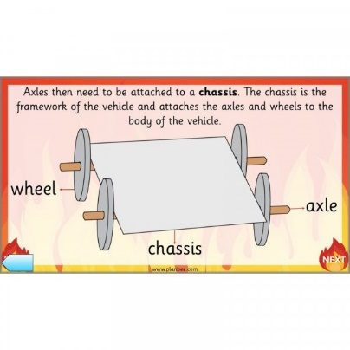
Key people / places
Woodhorn – the importance of the invention of wheel to mining towns locally

Resources
Selection of you vehicles Clothes pegs Masking tape
Card boxes Paper sticks PVA glue
Card Card discs Paint
Cotton MDF Wooden wheels Paint brushes
Reels Single hole punch Pens
Plastic tubing Card drill Decorative paper
Dowel Cutting mat Junior hacksaw
Vice Scissors

Assessment questions / outcomes
Can you tell me what an axel is?
Can you label this diagram?
Can you tell me what is wrong with this mechanism?
Were you happy with your moving toy?
What would you change?
Did it match your design?

