MORPETH FIRST SCHOOL

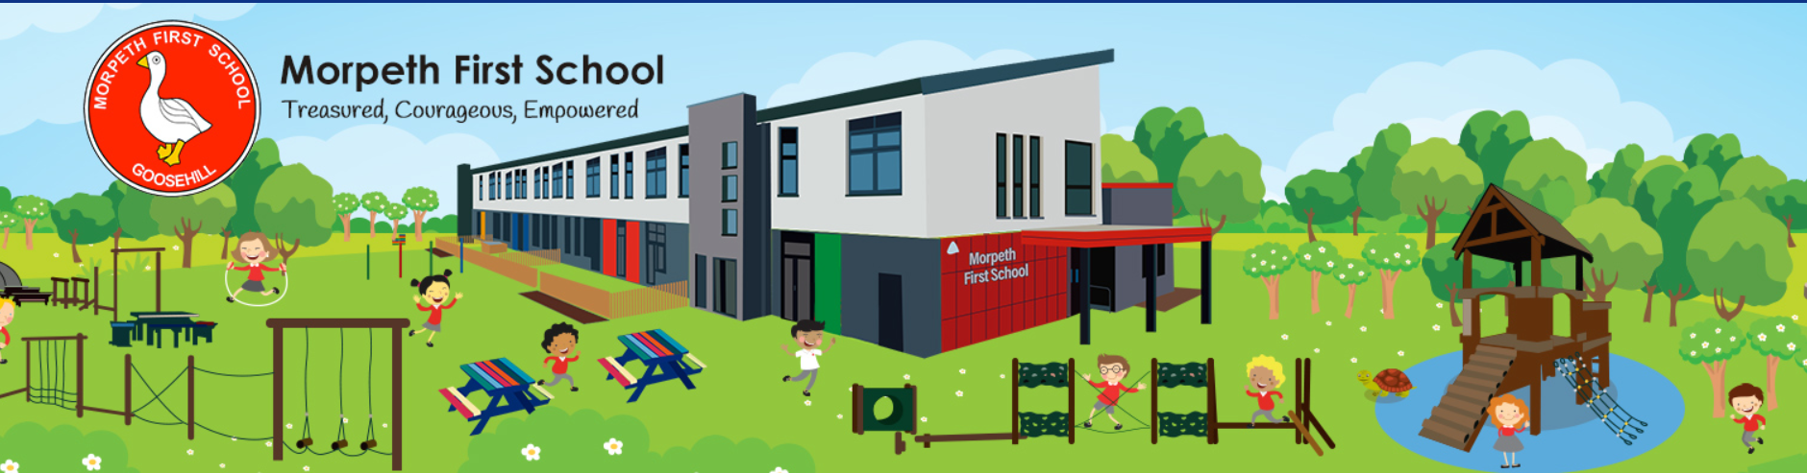

Uncollected Children Policy

MORPETH FIRST SCHOOL

Uncollected Children

Our school has the highest regard for the safety of the children in our care – from the moment they arrive to the moment that they leave.

The school’s uncollected children policy is part of the school’s policies for pastoral and safeguarding.

School closes at 3.15pm for Main School and at 11.45am and 3.30pm for Nursery sessions
Parents of children attending afterschool clubs will be informed of the finishing time of the club when signing up.

Safeguarding Safeguarding Leads
Designated Officer Mrs N Fielding, Headteacher
Deputy Officer Mrs S Bell Deputy Headteacher

At the end of every session [morning or afternoon], the school will ensure that all children are collected by a parent, carer or designated adult. If for some reason a child is not collected at the end of a session or after a club, the following procedures will be activated.

• If a parent, carer or designated adult is more than 15 minutes late in collecting their child, the Headteacher or senior member of staff will be informed.

• The Headteacher or senior member of staff will call the parent, carer or designated adult, and use any other emergency contact details available in order to try to ascertain the cause for the delay and how long it is likely to last. Messages will always be left on any answerphone requesting a prompt reply. It is therefore imperative that emergency numbers are kept up to date and the office informed whenever they are changed.

• Whilst waiting to be collected, the child will be supervised by at least two members of staff, at the school office, who will offer them as much support and reassurance as is necessary. The child will be able to access the After-school club provision, provided that the child is registered and there is an available place.

• If, after repeated attempts, no contact is made with the parent, carer or designated adult by 4.30pm, the Headteacher/senior member of staff will call the local Children Services department for advice.

• In the event of Children’s Services being called and responsibility for the child being passed to a child protection agency, the Headteacher/senior member of staff will attempt to leave a further telephone message with the parent/carer or designated adults’ answerphone. Furthermore, a note will be left on the door of the School’s premises informing the parent, carer or designated adult of what has happened. The note will reassure them of their child’s safety and instruct them to contact the local Children’s Services department.

• Under no circumstances will a child be taken to the home of a member of staff, or away from the School’s premises unless absolutely necessary, in the course of waiting for them to be collected at the end of a session.

• Under no circumstances will a child be left in the care of another parent without prior verbal permission from the uncollected child’s parent, carer or designated adult.

• The child will remain in the care of the school until they are collected by the parent, carer or designated adult, or alternatively placed in the care of Children’s services.

• Incidents of late collection will be recorded by the Headteacher/Senior member of staff and discussed with parents/carers at the earliest opportunity.

If parents and carers are late in collecting from the After-School Club, they are informed of the Child Welfare policy, the procedures instigated at 5.55pm and the need to contact Children’s Services in Appendix D of Roundabout’s procedures.

As a school, we understand that occasionally an unexpected incident arises where a parent or designated person is unavoidably detained by a few minutes. In this instance, every attempt should be made by the parent/carer to alert the office staff prior to the end of the day so that staff and the child/children can be forewarned. If the delay is likely to be longer than 15 minutes, parents should ensure that other arrangements are made for collecting their child and the office informed of these as soon as possible to minimise any anxiety or worries for the child.

Signed _______________________________ Chair of Governors

Date ___________________

Review Date 2023

